COVIDBookingHub

**Documentation**

# Certificate

This certificate is to certify that

Muhammad Daniyal

*Has Successfully Designed and Developed*

*COVIDBookingHub*

________________________________

### Dated: 27-Sep-2023

# Certificate

This certificate is to certify that

AfifaMaryam

*Has Successfully Designed and Developed*

*COVIDBookingHub*

________________________________

### Dated: 27-Sep-2023

# Certificate

This certificate is to certify that

Muhammad Umer Farooq

*Has Successfully Designed and Developed*

*COVIDBookingHub*

________________________________

### Dated: 27-Sep-2023

### Project Overview

The COVIDBookingHub E-Project represents the culmination of an entire semester's worth of hard work and dedication. This PHP-based web application has been meticulously developed to address the pressing challenges posed by the ongoing COVID-19 pandemic. With its three specialized portals—Admin, Hospital, and Patient—this platform offers a comprehensive solution for managing critical resources and interactions in these trying times.

### Academic Significance

This e-project is the result of rigorous academic endeavors, reflecting your commitment to mastering the art of web development, database management, and system architecture. It demonstrates your ability to apply theoretical knowledge and practical skills acquired throughout the semester.

### Target Audience

This documentation serves as both a testament to your academic journey and a comprehensive guide for anyone interested in understanding the intricacies of the COVIDBookingHub E-Project. Whether you are a fellow student, a professor evaluating the project, or a potential user seeking insights into the application's functionalities, this documentation provides a detailed walkthrough of the entire project.

Technology

COVIDBookingHub harnesses the power of PHP and MySQL to create a dynamic and responsive web application. PHP, a versatile scripting language, forms the backbone of our project, facilitating server-side scripting for seamless user interactions. MySQL, a robust relational database management system, provides a secure and efficient repository for storing and retrieving essential healthcare data.

## Admin Portal

1. **Introduction**
   * **Admin Portal Overview:** The Admin portal of COVIDBookingHub provides administrators with comprehensive tools to manage hospitals, vaccines, patients, and user interactions.
2. **Getting Started**
   * **Accessing the Admin Portal:** Describe how administrators can access the Admin portal.
   * **Login:** Provide instructions for logging in with administrator credentials.

**Username:** Admin@Sitee

**Password:** Admin@123

1. **Dashboard**
   * **Overview:** The Admin Dashboard provides an at-a-glance view of critical information.
   * **Dashboard Widgets:**
     + Current Hospitals: Number of active hospitals.
     + Pending Hospitals: Number of hospitals awaiting approval.
     + Rejected Hospitals: Number of hospitals denied approval.
     + Available Vaccines: Count of vaccines in stock.
     + Total Vaccines: Total vaccines registered.
     + Unavailable Vaccines: Count of out-of-stock vaccines.
     + Current Users (Patients): Number of registered patients.
     + User Requests (Patients): Number of patient registration requests.
     + Rejected Users (Patients): Number of denied patient registrations.
2. **Hospital List**
   * **Overview:** This section allows administrators to manage hospitals.
   * **Filters:** Admins can filter hospitals by status (rejected, accepted, or pending).
   * **Actions:** Approve or reject hospital registration (APPROVAL) requests.
3. **Patient List**
   * **Overview:** Similar to the Hospital List, administrators can manage patients here.
   * **Filters:** Filter patients by status (rejected, accepted, or pending).
   * **Actions:** Approve or reject patient registration requests.
4. **Vaccine List**
   * **Overview:** Admins can view and manage vaccines added by hospitals.
   * **Filters:** Filter vaccines by availability (available or unavailable).
5. **Messages**
   * **Overview:** View and manage messages from the Contact Us page.
   * **Search Functionality:** Admins can search for specific messages.
6. **Settings**
   * **User Name Change:** Instructions for changing the admin's username.
     + Security: Admins need to enter their current password for this change.
   * **Password Change:** Instructions for changing the admin's password.

Admin Portal Images:

Dashoard:

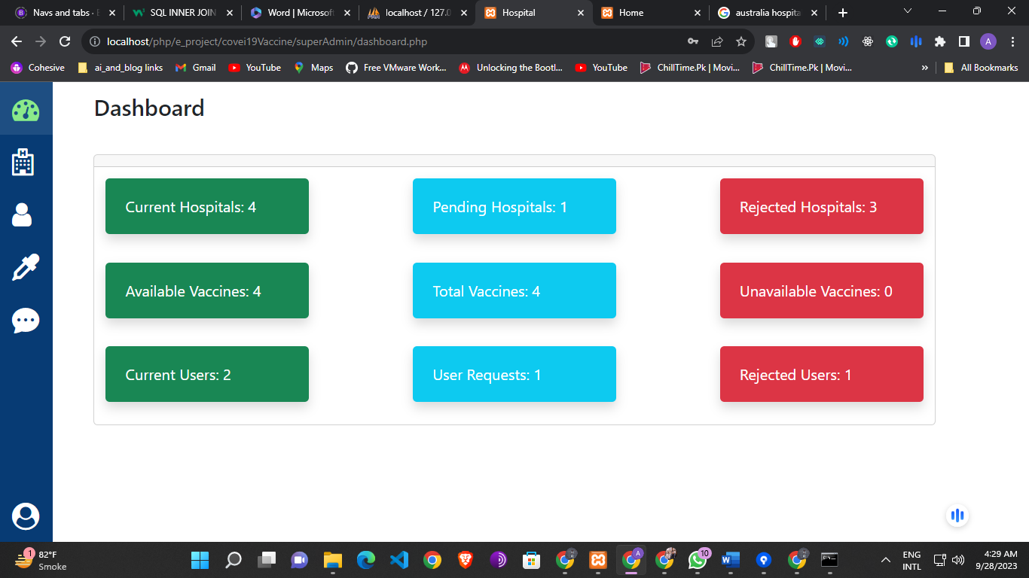

### Hospital List:

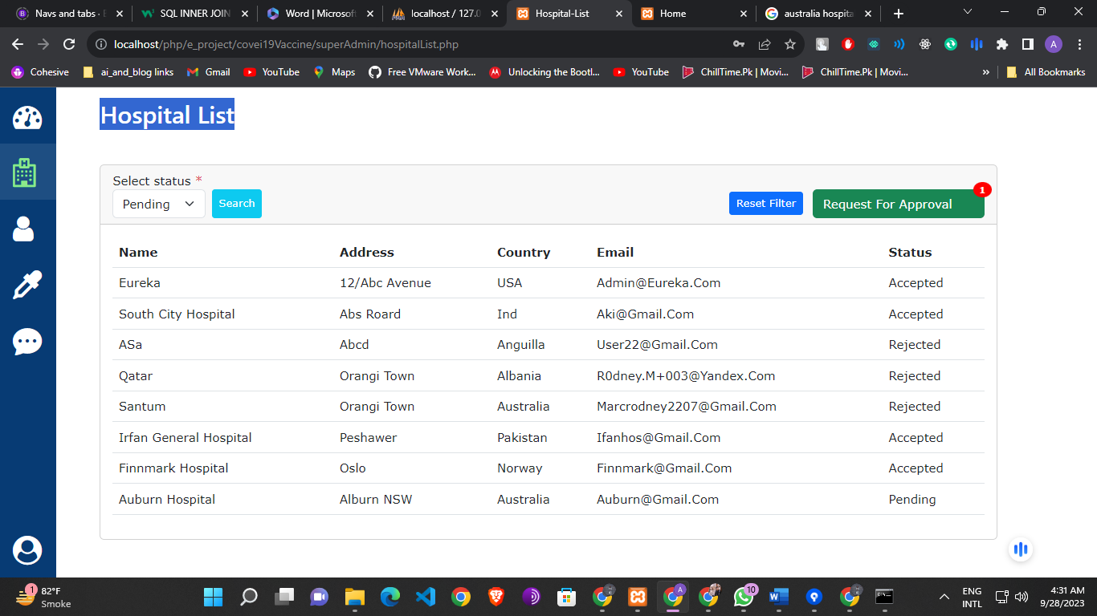

### Hospital Requests:

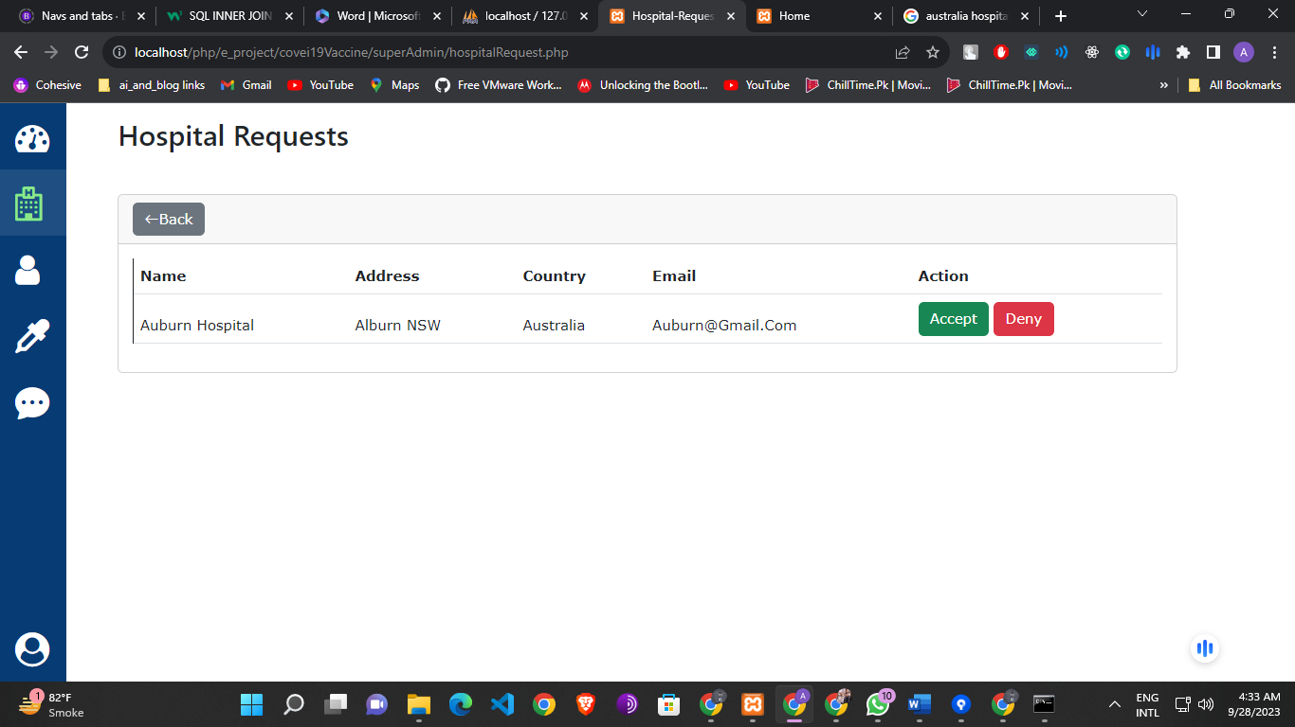

### Patient/User List:

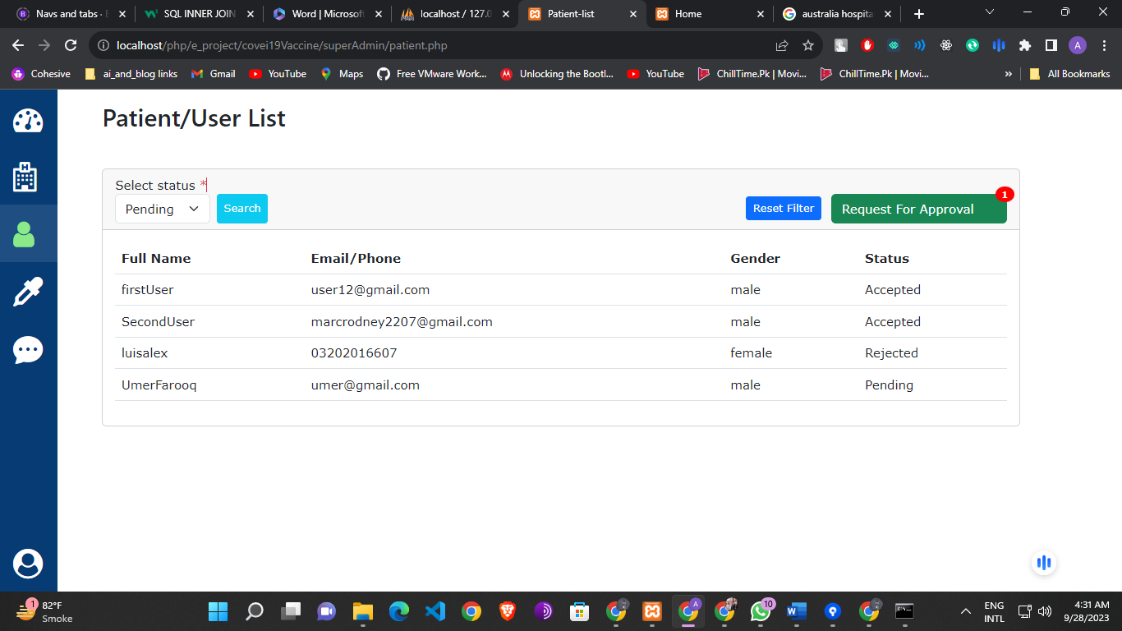

### User Requests:

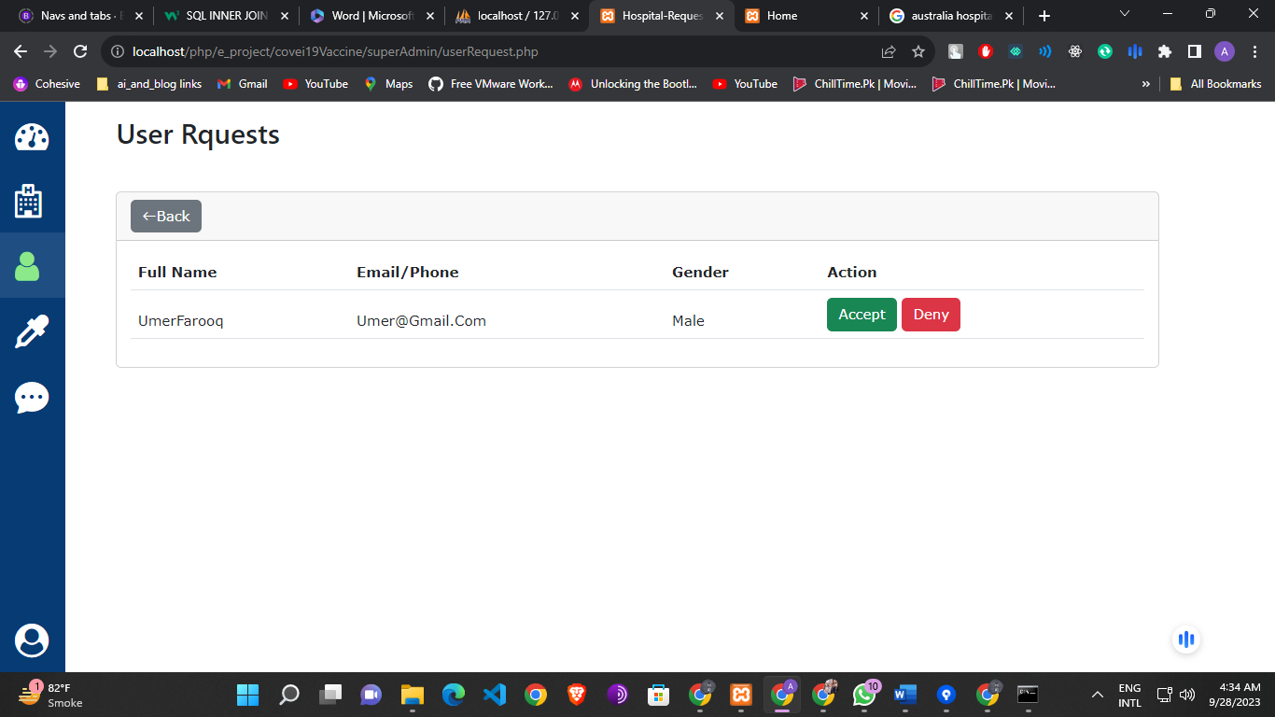

### Vaccine List:

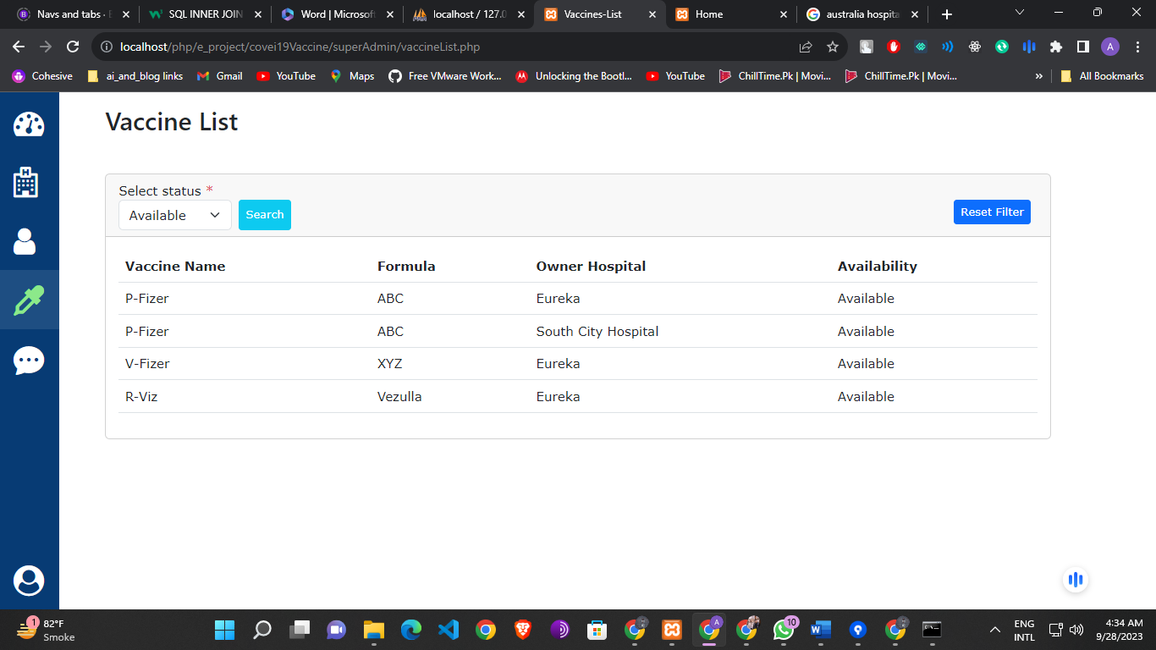

### Messages:

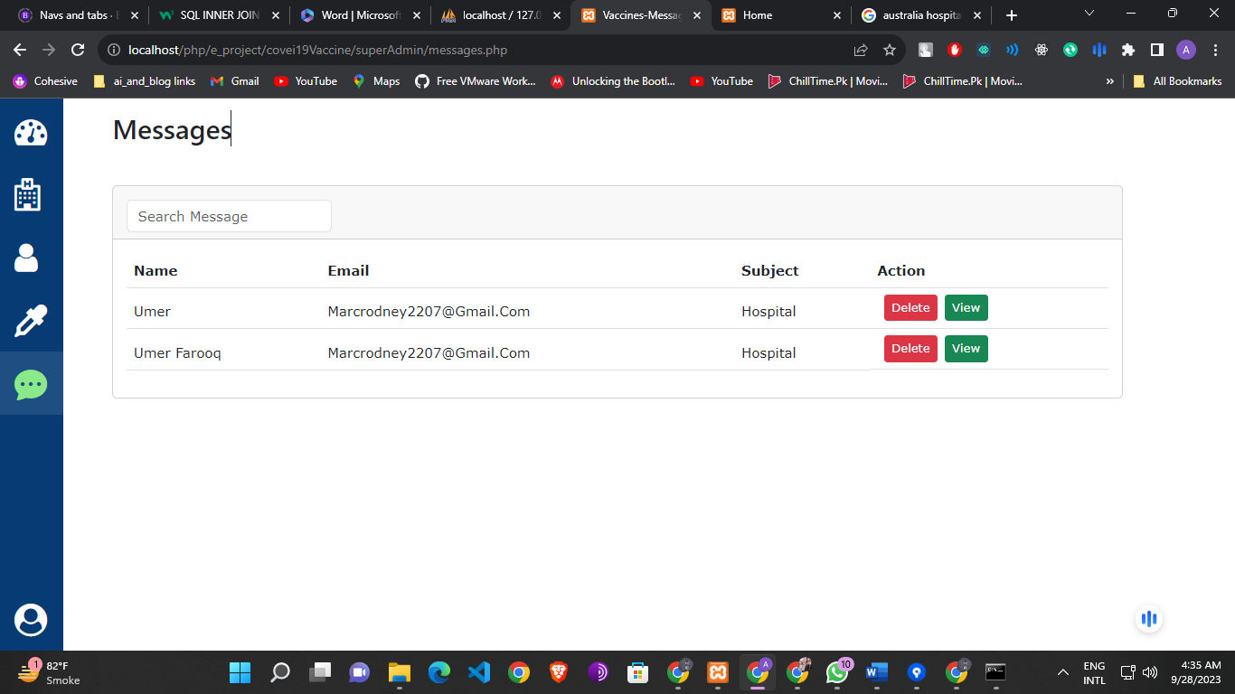

### Setting:

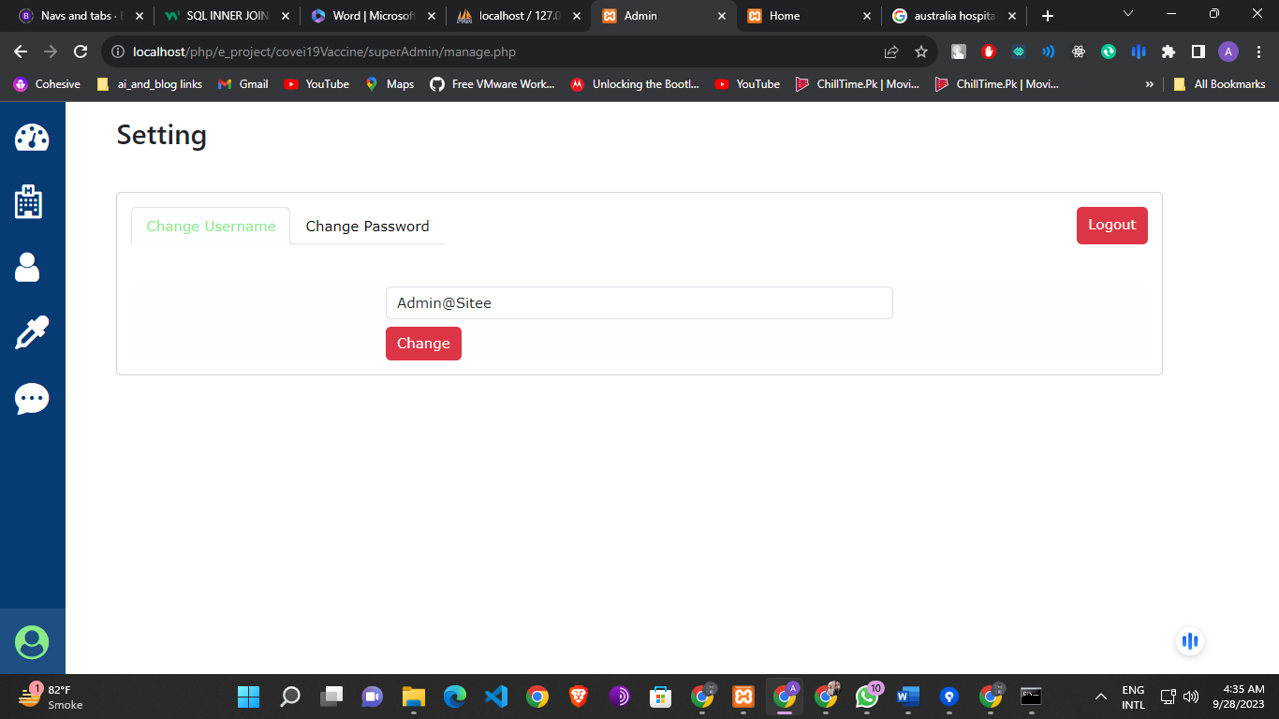

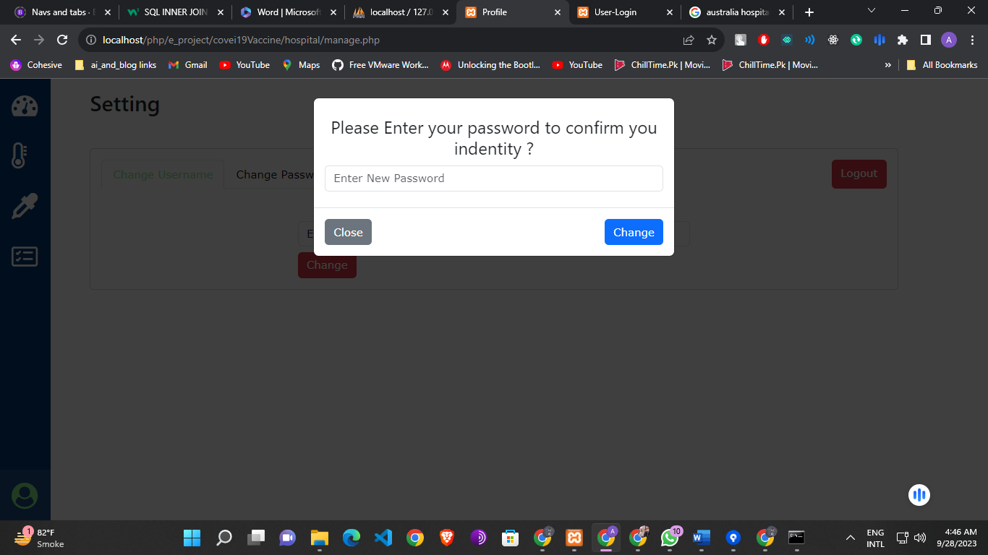

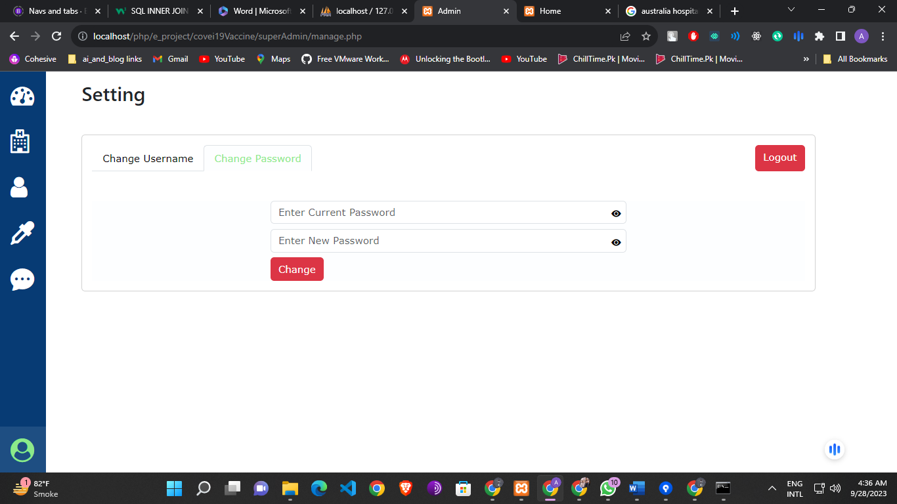

## Hospital Portal

1. **Introduction**
   * **Hospital Portal Overview:** The Hospital portal of COVIDBookingHub is designed to empower healthcare facilities to efficiently manage test appointments, vaccination appointments, and vaccine inventory during the COVID-19 pandemic.
2. **Getting Started**
   * **Login:** Describe how hospitals can log in using their unique username and password and also only those hospital will signIn that will be approved by admin.
   * **Sign Up:** Instructions for hospitals to create an account if they don't have one.

After attempt signup admin get an request for register and if admin can approve it the hospital user can be signIn

1. **Dashboard**
   * **Overview:** The Hospital Dashboard provides a quick overview of critical information.
   * **Displayed Information:**
     + Hospital Name: Displayed prominently at the top of the dashboard.
     + Test Requests: Number of pending test requests.
     + Test Appointments: Number of upcoming test appointments.
     + Vaccination Requests: Number of pending vaccination requests.
     + Vaccination Appointments: Number of upcoming vaccination appointments.
     + Total Number of Vaccines: Current vaccine inventory count.
2. **Test Appointment Approve Page**
   * **Overview:** Hospitals can manage test appointments here.
   * **Filters:** Filter appointments by status (accepted, rejected).
   * **Actions:**
     + Approve or reject pending test appointment requests.
     + Add test results for completed appointments.
     + View a list of all test results.
3. **Vaccination Appointment Approve Page**
   * **Overview:** Similar to the Test Appointment Approve Page, hospitals manage vaccination appointments here.
   * **Filters:** Filter appointments by status (accepted, rejected).
   * **Actions:**
     + Approve or reject pending vaccination appointment requests.
     + Add vaccination results for completed appointments.
     + View a list of all vaccination results.
4. **Vaccine List**
   * **Overview:** Hospitals can manage vaccine inventory
   * **Actions:**
     + Add new vaccines to inventory.
     + Update the availability status of vaccines.
     + Delete vaccines that are no longer in use.
5. **Settings**
   * **User Name Change:** Instructions for hospitals to change their username.
     + Security: Hospitals must confirm their current password for this change.
   * **Password Change:** Instructions for hospitals to change their password.

Hospital Portal Images:

Dashboard:

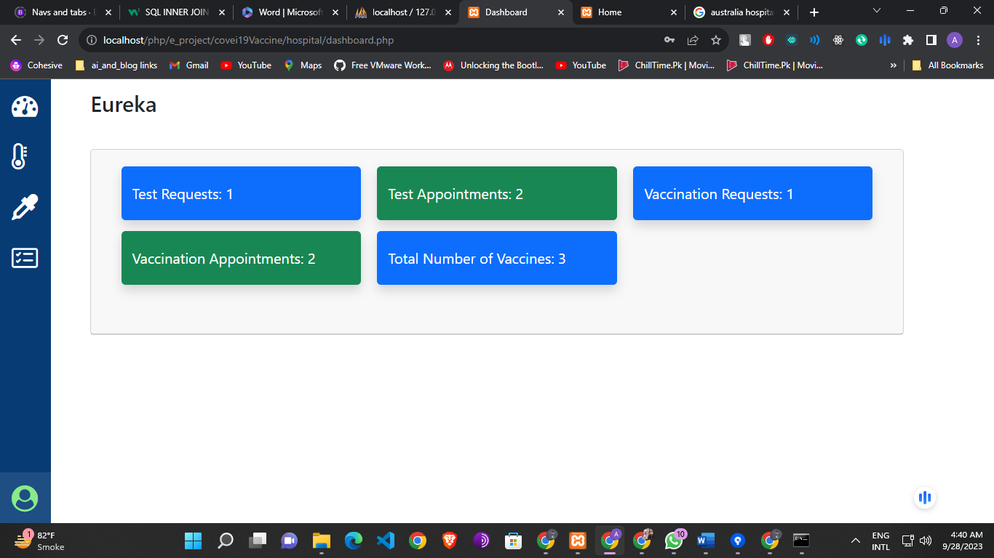

Test Appointment Approved:

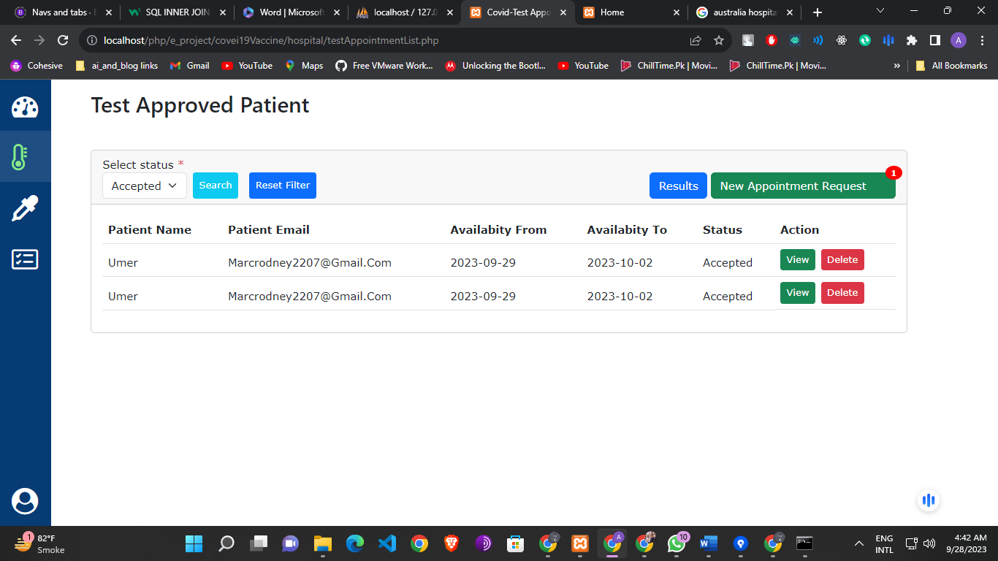

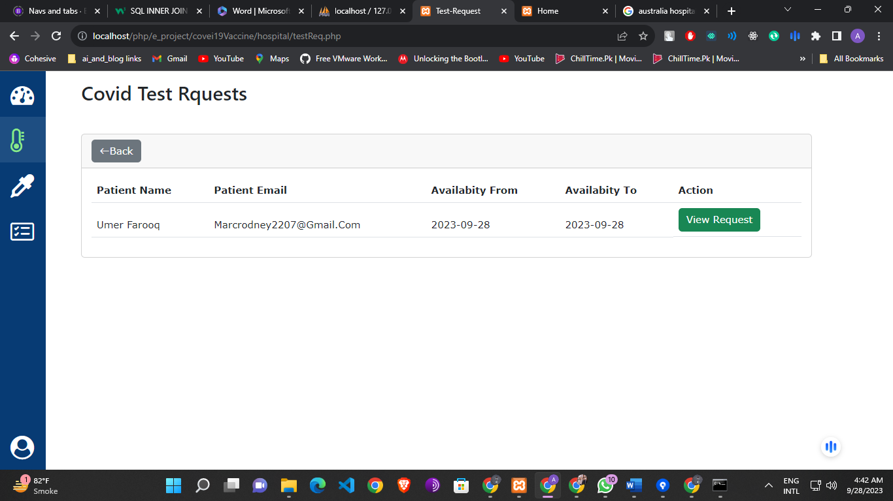

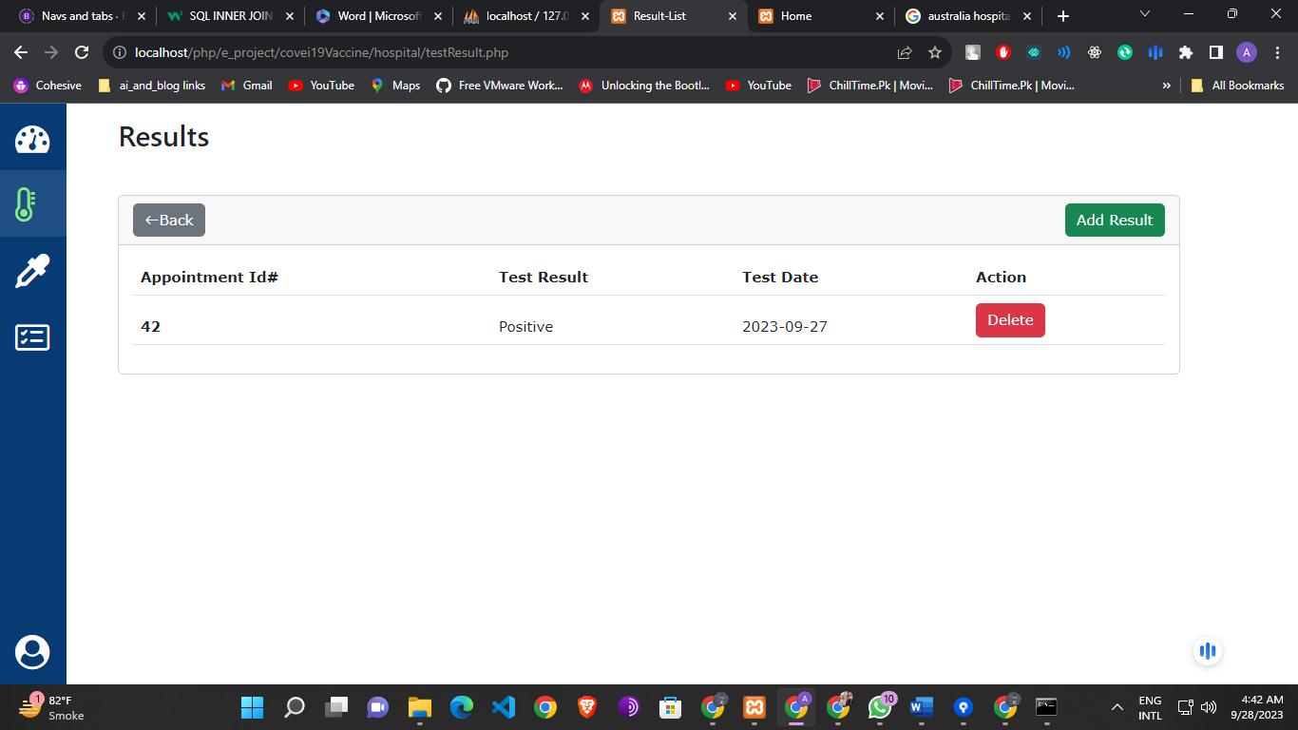

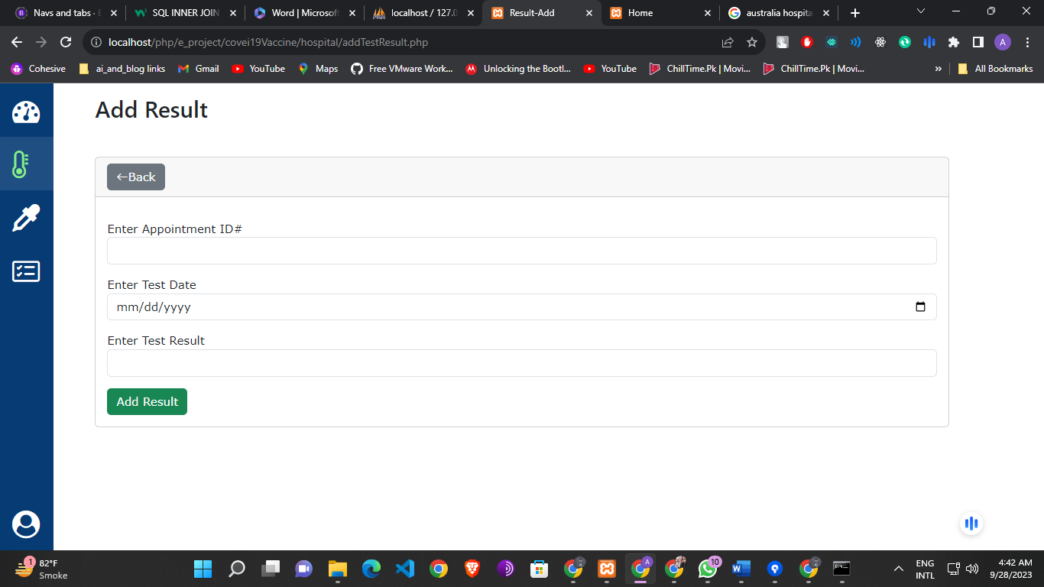

Vaccination Appointment Approved:

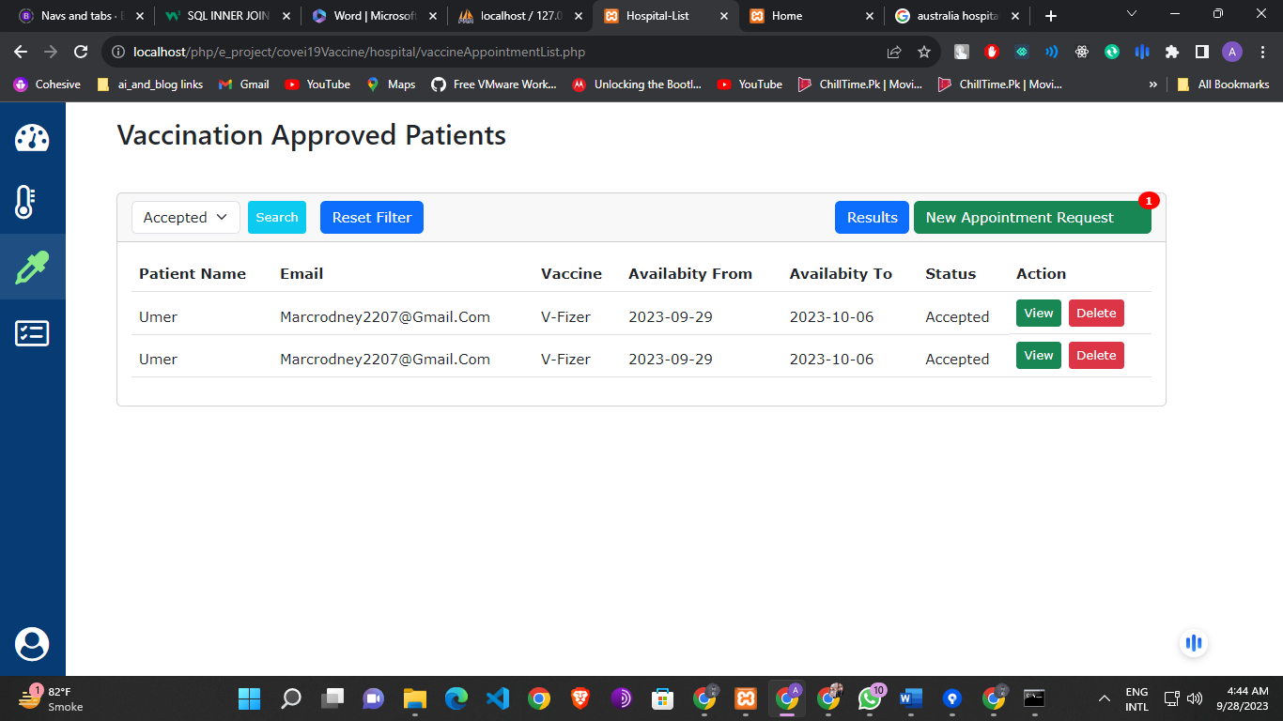

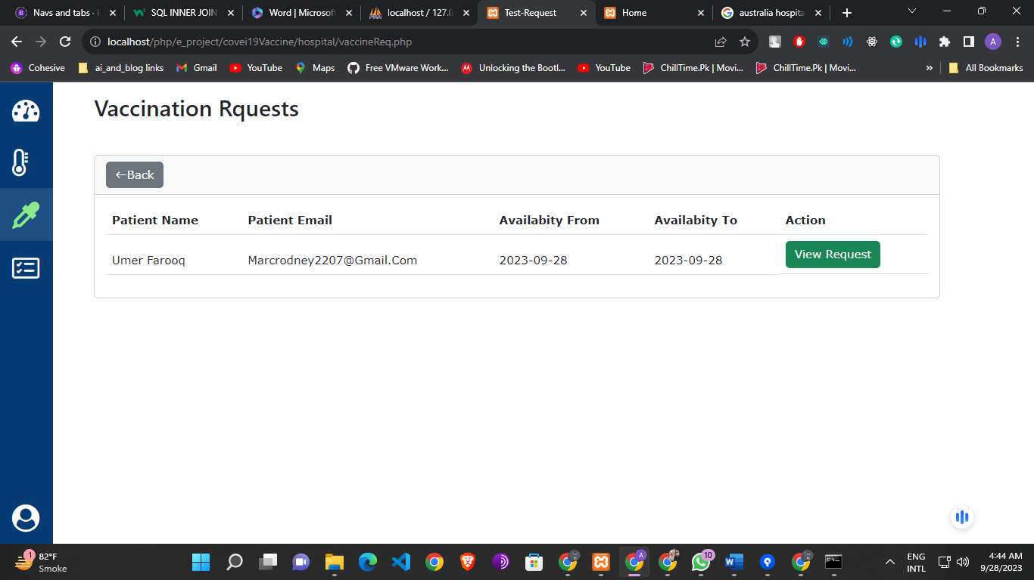

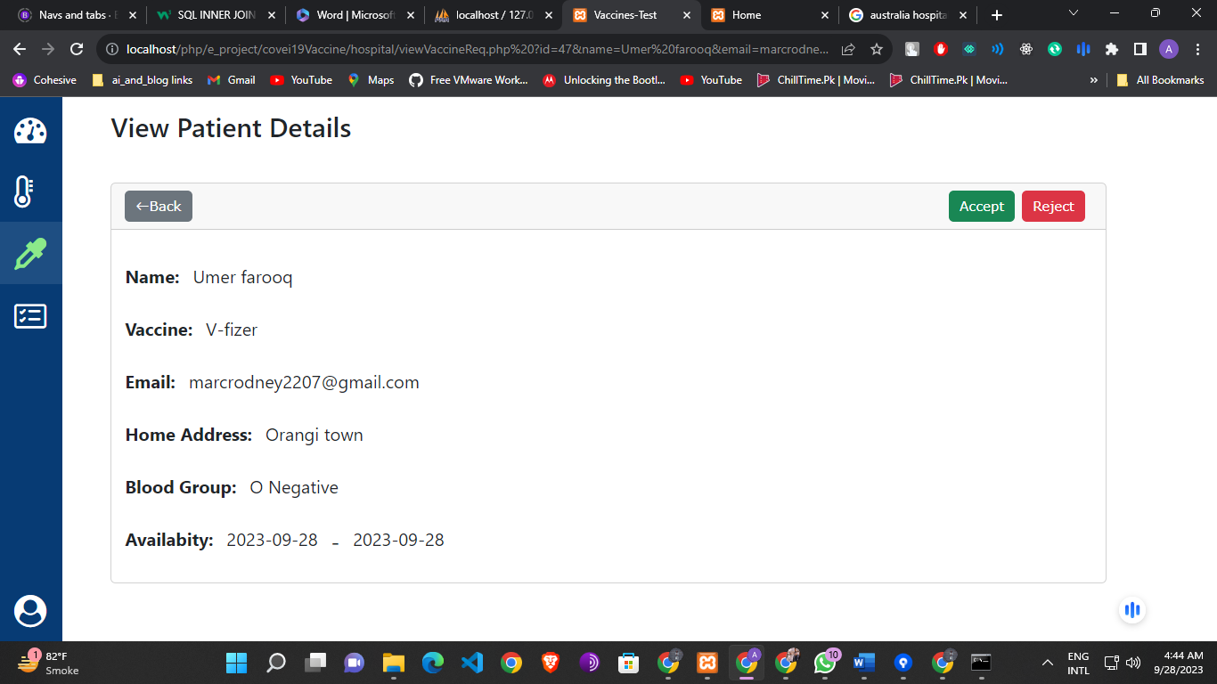

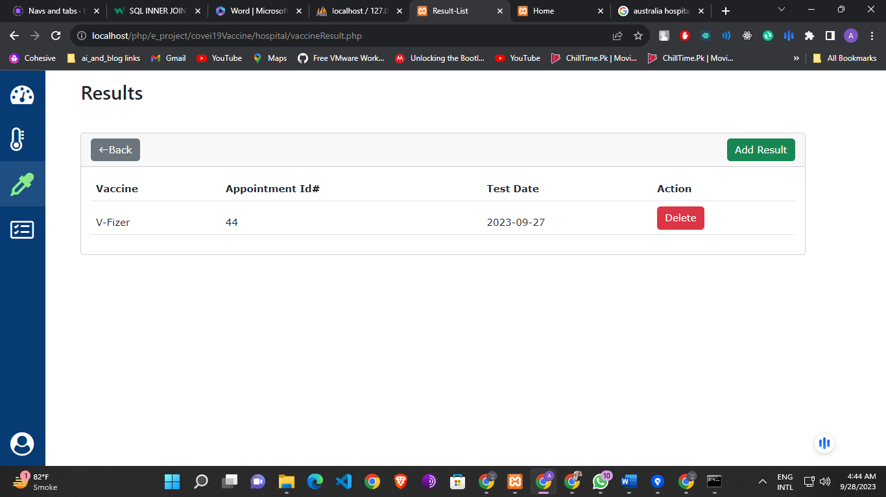

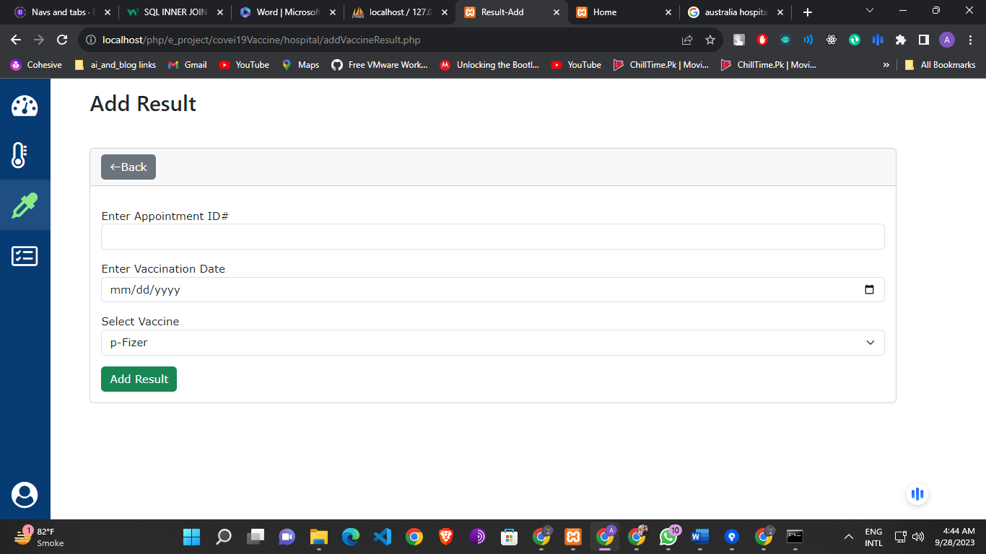

Vaccine List:

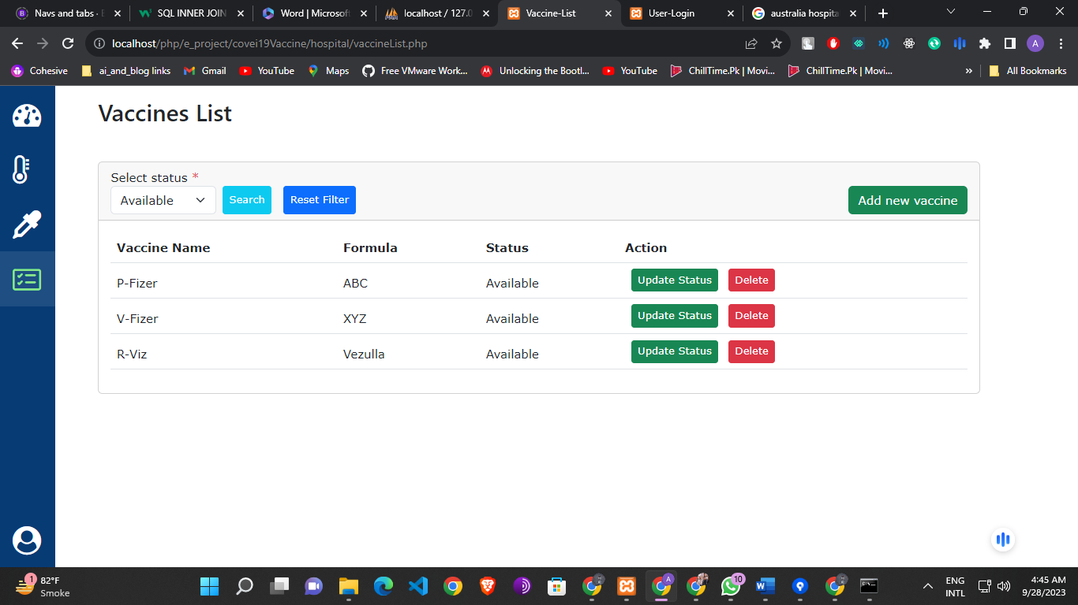

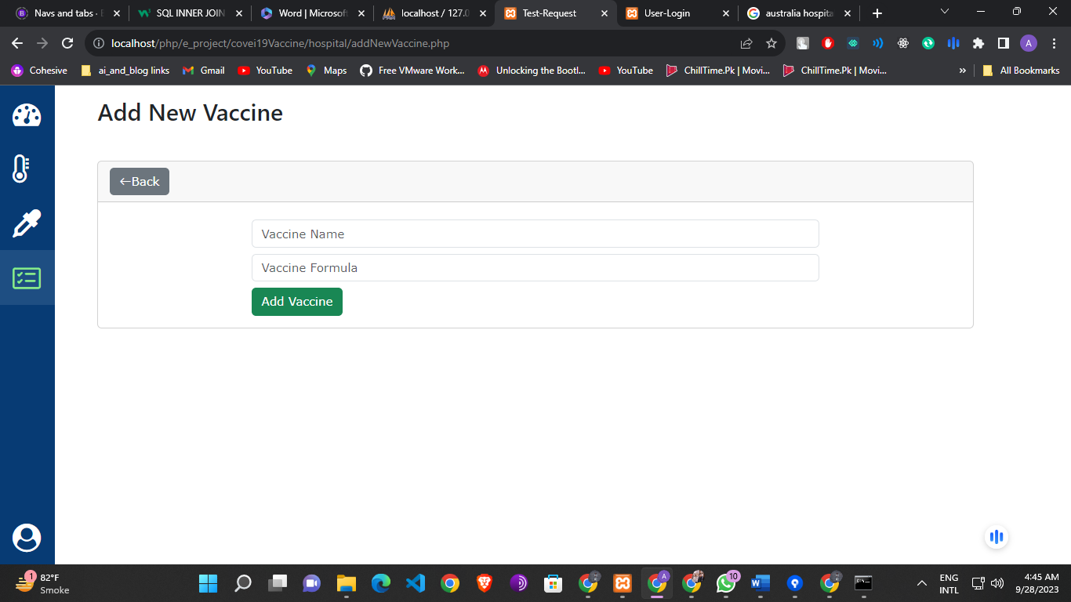

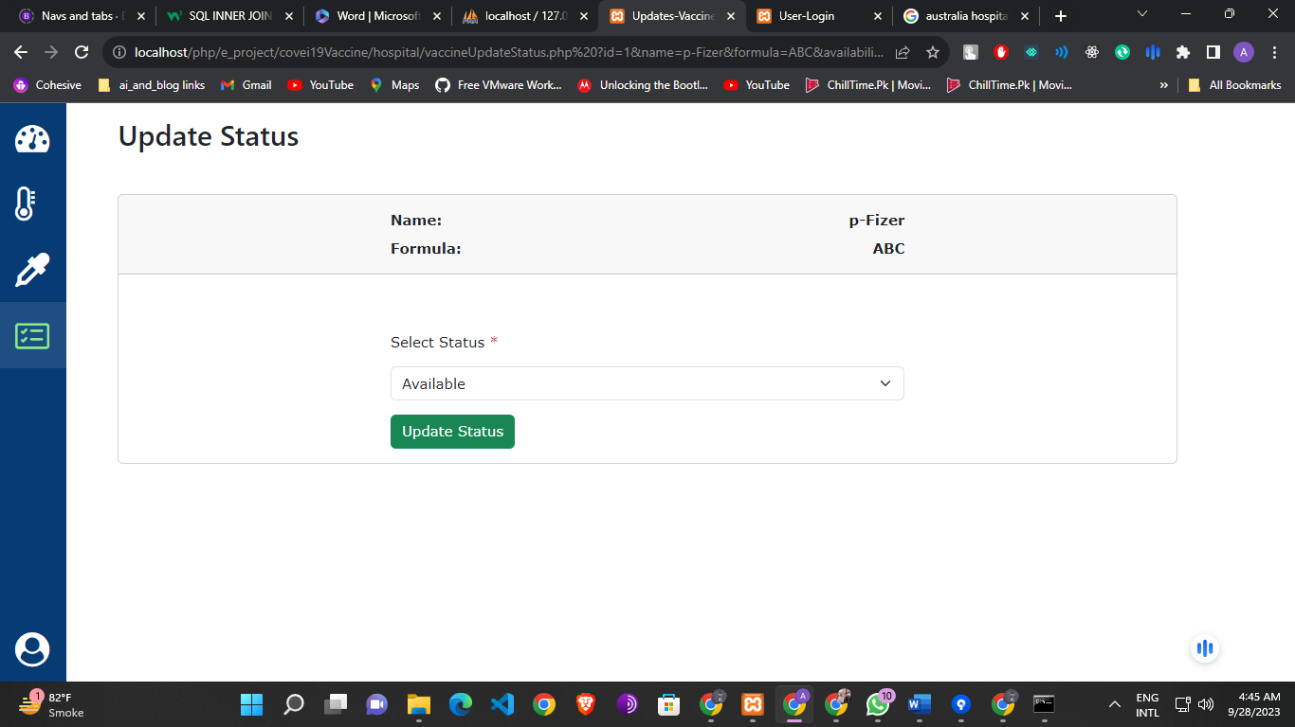

Setting:

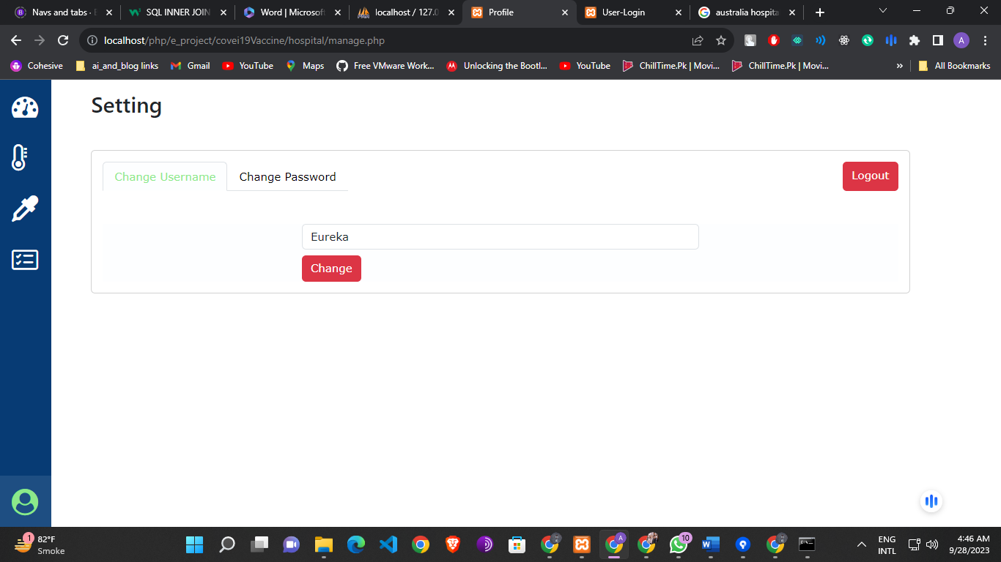



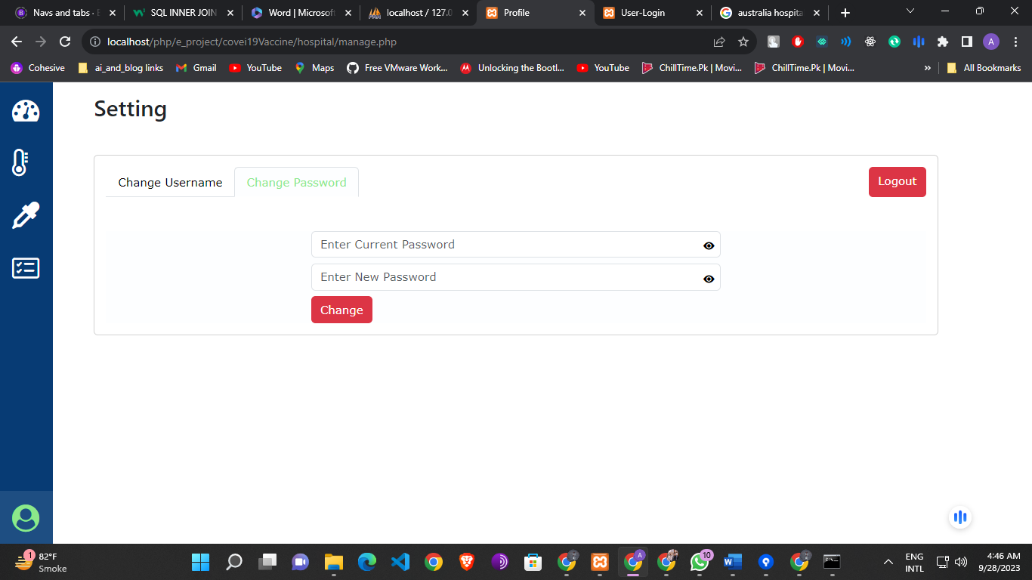

## Patient Portal

1. **ntroduction**
   * **Patient Portal Overview:** The Patient portal of COVIDBookingHub allows individuals to access healthcare services efficiently by scheduling test and vaccination appointments, viewing appointment details, accessing test and vaccination results, and contacting administrators.
2. **Getting Started**
   * **Home:** General information about COVIDBookingHub and the services it offers, accessible without the need for login.
   * **Login:** Instructions for patients to log in using their credentials.
   * **Register:** Details on how patients can create an account if they are new users.
3. **Hospitals**
   * **Overview:** Patients can browse hospitals and request appointments here.
   * **Hospital Details:** View hospital information and available services.
   * **Appointment Request:**
     + Test Appointment Request: Patients fill out required fields to request a test appointment.
     + Vaccination Appointment Request: Patients select a vaccine from the available options and fill out the appointment request form.
4. **My Appointment Details**
   * **Overview:** Patients can view a list of their scheduled appointments.
   * **Appointment Information:** View details of each appointment, including status and date.
5. **Results**
   * **Overview:** Patients can access their test and vaccination results.
   * **Result Details:** View detailed results of tests and vaccinations.
6. **Contact Us**
   * **Overview:** Patients can submit queries and messages to administrators.
   * **Message Submission:** Explain how patients can submit queries and messages to administrators.
7. **Settings**

* **User Name Change:** Instructions for patients to change their username.
  + Security: Patients must confirm their current password for this change.
* **Password Change:** Instructions for patients to change their password.

Patient Portal Images:

Home Page:



Hospitals:





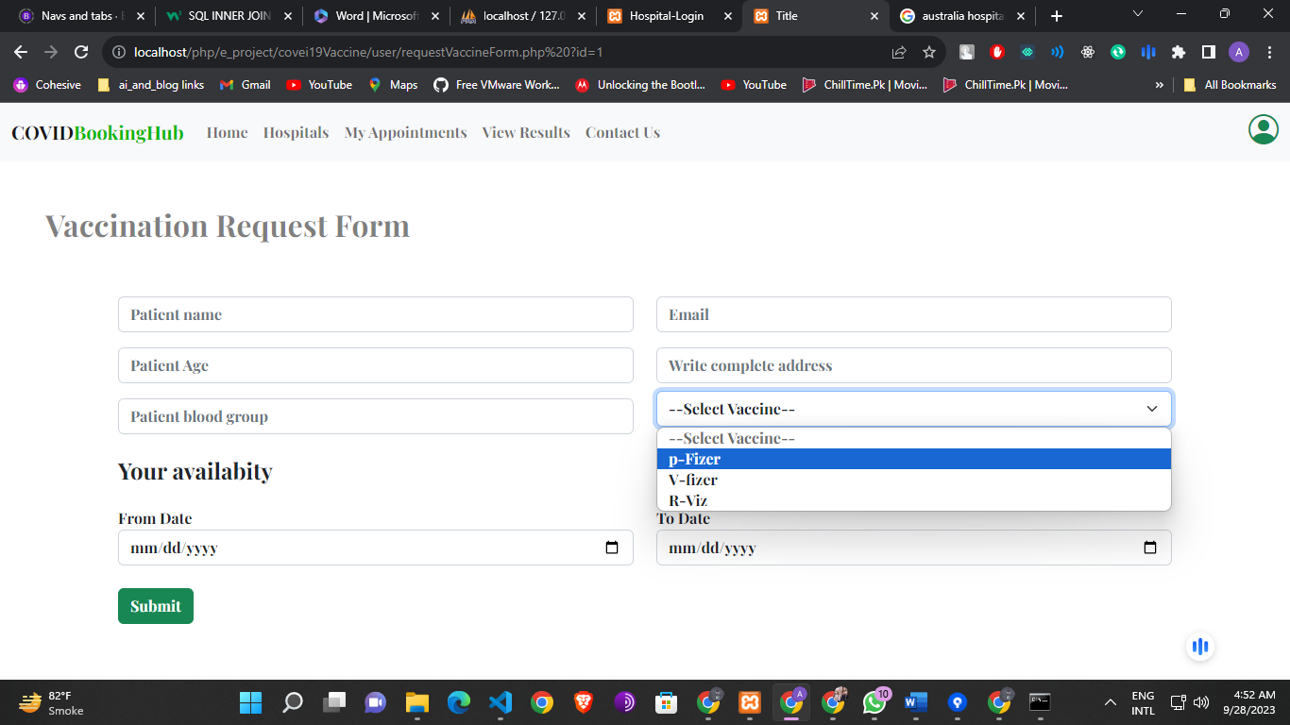

### My Appointments:





Results:

 

Contact Us:

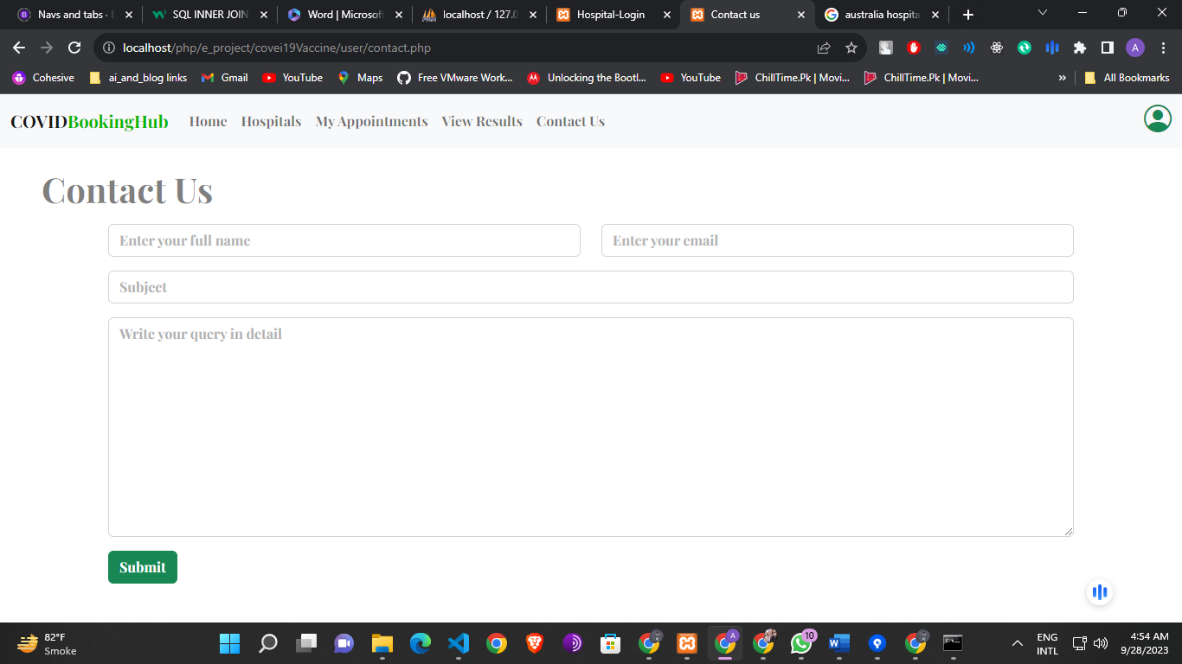

Setting:





